YAWKEY BASEBALL LEAGUE HALL OF FAME CLASS OF 2023

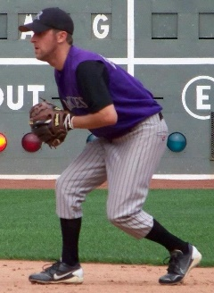
AJ “Booch” Bucciarelli spent his entire 15-year YBL career with the Revere Rockies, serving as one of the best second basemen in the league, as well as a 7-time all-star who was always a tough out. Booch was a part of more than 200 wins and eight 20-win seasons for the Rockies, and his personal statistics speak for themselves - 254 hits, .331 career average, 184 runs, and 94 RBIs. He was also a staple for the Rockies organization after Brian Cooper retired, running the team for many years and managing all operations. He was also the face of recruiting top talent to the team and league. Always the consummate teammate, his dedication to the Rockies and league was at the highest level.

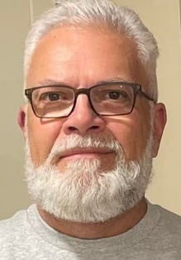
Dominic DiMare was a premiere umpire in the YBL for over 20 years, also serving as the league’s Umpire-in-Chief for a 3-year span. In addition to being regarded as one of the best and most-liked umpires in the league, Dom was also named to the Umpire Crew for 14 all-star games, with four taking place at historic Fenway Park. For his meritorious service, Dom was called on to umpire in more than twenty-five playoff series, including ten championship series. Although proud of all of his accomplishments, Dom felt the most pride in seeing his sons, Mike and Ryan involved in the YBL, on the field as a player and behind the dish as an umpire.

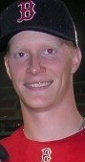
Sean Gildea played 7 seasons in the YBL from 2004 – 2010, all with the Medford Maddogs, winning 46 games on the mound with only 15 losses, and saving 5 games. As one of the dominant pitchers in the league each year, he took that a step further by winning the 2007 Cy Young Award as the best pitcher in the league. His 46 wins and 501 strikeouts rank him 4th all-time in each category, along with a stellar 1.62 career era and 377 innings pitched.
He had 18 games with 10 or more strikeouts, with a high of 19 K’s in a game in 2005 and tossed a no hitter in 2006. Sean also appeared in 4 all-star games.

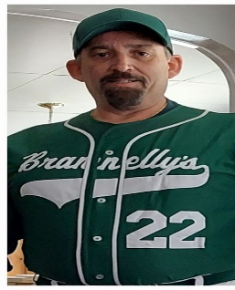
Russell Grant joined the then Junior Park league in 1985 as a player for Roslindale Parkway and moved to the coaching staff due to injuries in 1988, when the team merged with Brannelly’s and won a championship. They followed that up with Stewart Memorial Tournament championships in 1989 and 1990, and Russ was a proud member of the 1993 coaching staff at the all-star game at Fenway Park, as well as chair of the 1993 awards banquet. As a player, coach, builder and franchise holder, Russ was a true leader on and off the field, as well as a quality role model for many younger athletes that donned the Parkway/Brannelly’s uniforms.
YBL GOLF TOURNAMENT ! Please join current players, coaches, alumni, umpires and friends on Saturday, August 19th at noon at George Wright Golf Course in Hyde Park. $140 per player provides golf, cart, lunch, gift bag and lots of prizes and raffle items. Players and sponsors needed! We’ll also be pulling the winner of the Wade Boggs Autographed Sox Jersey that day (tickets are $10, 3 for $25, 7 for $50). Contact joeohara64@hotmail.com for info on either. All proceeds to benefit league operating costs!
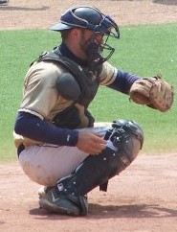
Tony Iafolla was one of the most feared hitters in the YBL for over 15 years. A perennial all-star and gold glover, with a cannon behind the plate, Tony was in the MVP discussion nearly every year, and won the MVP in 2009, when he led the league with 7 homers and 39 runs batted in. Since the advent of the .400 hitter, Tony is the YBL career leader with 32 home runs and 328 runs batted in, second in walks and doubles, third in runs and holds a .365 lifetime average. Tony made eleven all-star appearances.

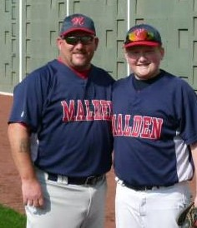
John “Smokey” Moore has had a huge impact on the game of baseball for many years. John and Kevin McGovern built a tremendous Malden Franchise that always challenged for the league title. After a brief stint on the Somerville staff, Smokey came to the rescue when Dave McKay was unable to run the McKay Club due to illness. John saved the franchise and continued to work with Dave to bring in top collegiate and inner-city talent to improve the McKay Club from a 3-win season to a Semi Final contender. Smokey has been a leader in bringing a positive, fun atmosphere to the diamond, but he was also a serious competitor. A past member of the YBL Board and Manager of our YBL EMASS Classic Championship team, Smokey also created a $500 scholarship named in honor of his beloved Dad, Tim, for a local player in need each year. He also organized a baseball game in support of Toys for Tots every December.
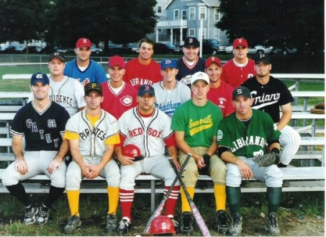
The 1999 Somerville Alibrandi’s Team had one of the most impressive seasons in the history of the YBL with a 23-5 record and an undefeated playoffs to earn the team’s 2nd championship out of an eventual 9 straight titles! The team was led by a starting rotation of Shawn Nadeau, Joe Stanton and Brian Kosta that went a combined 30-0 with a sub 3 ERA.
Offensively, the team was anchored by its Hall of Fame infield of Kevin Doyle, David Treska, Kevin White, Chris Wright and Marc DesRoches.
The team hit .378 in the regular season and averaged 10 runs a game, then hit an amazing .422 in the playoffs, averaging 11 runs a game with 15 stolen bases and 15 homers in 10 games. Chris Wright led the team in that postseason with 20 hits, 8 HR and 20 RBIs and was named Playoff MVP. Third-year manager Mike Powers pushed all the right buttons, becoming the YBL’s Manager of the Year.
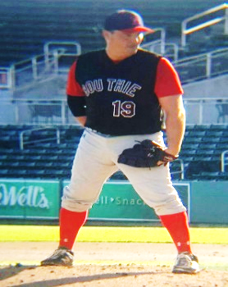
Rob Stephenson played for more than 20 years in the YBL for the Avi Nelson Club, T’s Pub and the South Boston Saints, going to the finals with the Saints once. He was a slugging first baseman, ace starting pitcher and powerful closer who was a fierce competitor in every aspect of his game. He appeared in 9 all-star games, including twice at Fenway Park, where he once hit a bomb into the left field screens. He did whatever it took to help his team win games and was a great role model for younger players on the team.

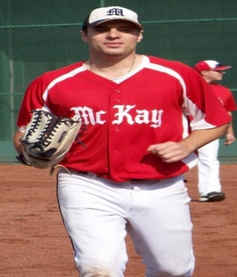
Drew Tambling was one of the best leadoff and #3 hitters in the history of the YBL. He was a speedster and a prolific hitter. Many of his flyouts were homers in several MLB parks. He owned a .385 lifetime average, and ranked 3rd all-time in the YBL with 21 homers; 4th with 18 triples and 5th with 123 stolen bases. He was in the running for the batting title in each of his 7 years played. He was one of the most consistent and feared hitters of his era but also worked very hard to make himself into a gold glove outfielder. A great and quiet leader always was his persona on and off the field.

